* **Git Installation On Windows**
* **Git bash interface**
* **Basics Git commands**
* **Create a local repository**
* **Connect to remote repository**
* **Push the file to GitHub**

1.We need to download Git using below link : <https://git-scm.com/downloads>

And then install Git Hub in local machine by selecting appropriate OS version(64 Bit)

2.Once Git has been installed successfully and Git bash interface will appear as below

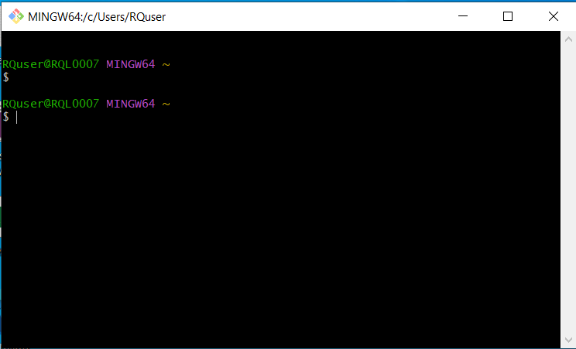

Basics commands for Git.

1. Check Git version

Git –version

1. Create a directory in local machine

Mkdir test

1. Move into test directory

cd test

1. Initialize a test directory

Git init

1. Check status of local directory which is created test.

Git status

1. Add some dummy contents in demo.txt file

Git add demo.txt

1. Commit the changes which we made

Git commit -m “committing a text file ”

1. Link git to github account

Git config –global user.username rqtest

1. Create repository in github.

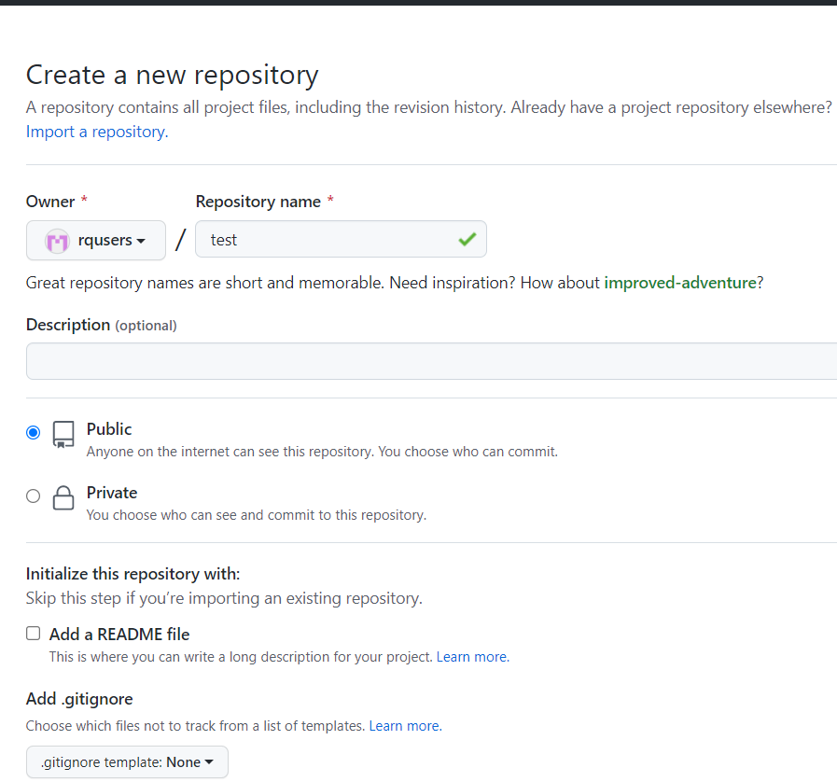

1. Link local to remote repository

Git remote add origin <https://github.com/rqusers/test.git>

This is successfully linked to remote repository.

1. Push local files to remote branch master

Git push origin master

